1. Pick any mobile app you use daily (like Zomato, Instagram, or Paytm), open its login or signup form, and identify 5 possible defects in the UI or workflow. Write each defect as a clear defect statement.

ANS:-

Defect ID: ZOM-001

Title: Login button remains enabled when mobile number field is empty Module: Login
Severity: Major Priority: High

Steps to Reproduce:

- Open Zomato application.
- Navigate to Login screen.
- Leave mobile number field blank.
- Observe Login button.

Expected Result:
Login button should remain disabled until a valid mobile number is entered.

Actual Result:
Login button remains enabled even when the mobile number field is empty. Defect ID: ZOM-002
Title: No validation message displayed for invalid mobile number Module: Login
Severity: Minor Priority: Medium Steps to Reproduce:
- Open Zomato Login page.
- Enter a mobile number with less than 10 digits.
- Click Continue.

Expected Result:
System should display an error message asking the user to enter a valid mobile number.

Actual Result:
No validation message is displayed. Defect ID: ZOM-003
Title: OTP field accepts alphabetic characters Module: OTP Verification
Severity: Major Priority: High

Steps to Reproduce:

- Enter a valid mobile number.
- Proceed to the OTP verification screen.
- Enter alphabetic characters in the OTP field.

Expected Result:
OTP field should accept only numeric values.

Actual Result:
OTP field accepts alphabetic characters. Defect ID: ZOM-004
Title: Resend OTP button remains disabled after timer completion Module: OTP Verification
Severity: Critical Priority: High

Steps to Reproduce:

  - Enter a valid mobile number.
  - Proceed to the OTP screen.
  - Wait for the OTP timer to expire.
  - Observe the Resend OTP button.

Expected Result:
Resend OTP button should become active after the timer expires.

Actual Result:
Resend OTP button remains disabled even after the timer expires.

Defect ID: ZOM-005

Title: Blank screen displayed after successful OTP verification Module: Login Workflow
Severity: Critical Priority: High

Steps to Reproduce:
- Open Zomato application.
- Enter a valid mobile number.
- Enter the correct OTP.
- Complete the verification process.

Expected Result:
User should be redirected to the Zomato home page after successful login.

Actual Result:
Application displays a blank screen instead of redirecting the user to the home page.

Application: Zomato

Environment: Android Mobile Application Reported By: Saksham Dave
Status: New Date: 24/06/2026

2. For each defect you found in the previous task, assign a Severity level (Blocker, Critical, Major, Minor, Trivial) and a Priority level (High,
Medium, Low). Briefly justify your choice for one defect where severity and priority are different.<br><br><em><strong>Hint:</strong> Think about how badly the defect impacts users (severity) versus how quickly it should be fixed (priority).</em>

Ans: Severity and Priority of Defect

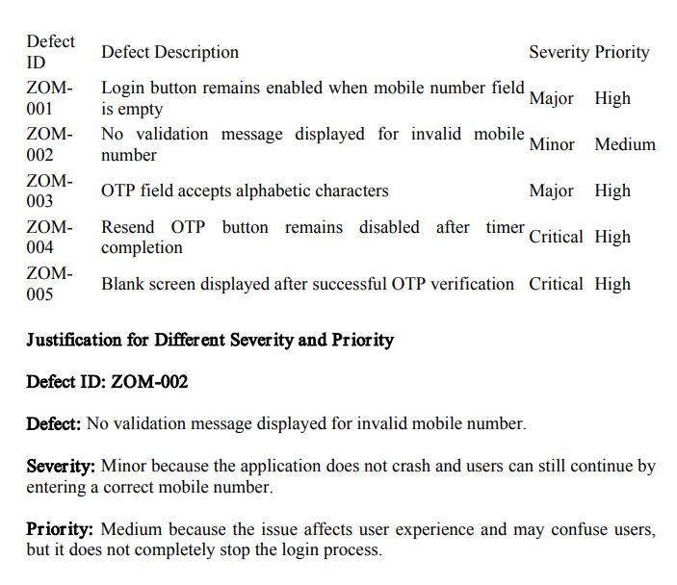

3. Draw a Bug Life Cycle diagram showing all the main states (New, Assigned, Open, Fixed, Retest, Verified, Closed, Rejected, Deferred, Duplicate, Not a Bug) and the transitions between them. You can use pen-paper and upload a photo, or use any diagram tool you like.

ANS:- Bug Life Cycle Diagram

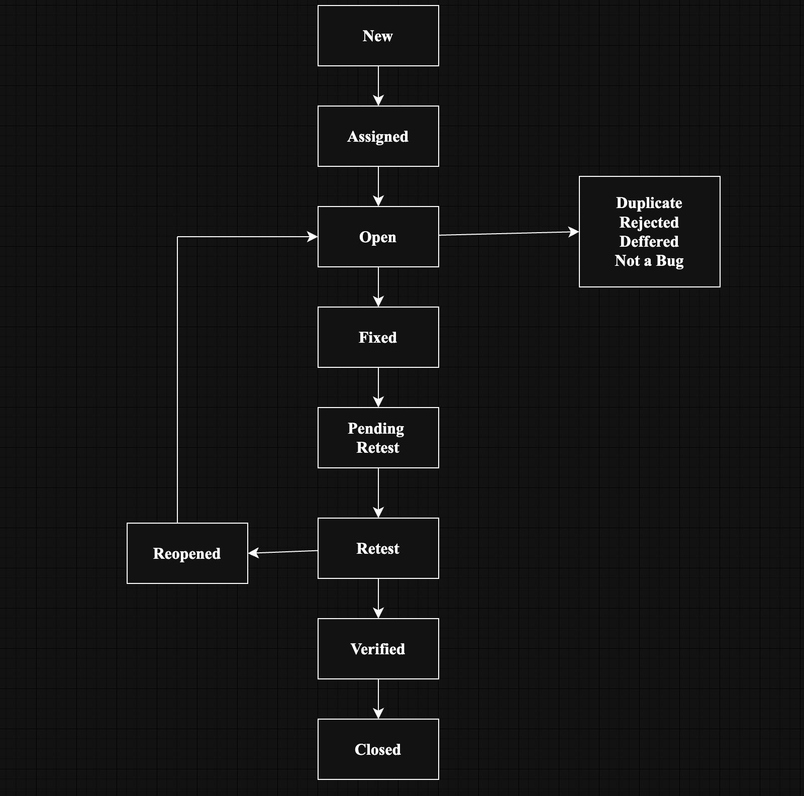

Explanation

New: Tester reports a new defect. Assigned: Defect is assigned to a developer.
Open: Developer starts working on the defect. Fixed: Developer fixes the defect.
Retest: Tester retests the fix.
Verified: Tester confirms the fix works. Closed: Defect is closed successfully.
Rejected: Defect is not accepted.

Deferred: Fix is postponed to a future release. Duplicate: Same defect already exists.
Not a Bug: Reported issue is working as designed.

4. Write a short scenario where a defect in a UPI payment feature (like in PhonePe or Paytm) is found very late—after the app is live. Explain in 4-5 lines how the cost and impact of fixing this defect would be different if it was caught during development instead.

ANS:- UPI Payment Defect Found After Release

A defect was discovered after the application went live where users were charged twice for a single UPI payment when they clicked the "Pay Now" button multiple times due to a slow network connection. As a result, customers lost extra money and raised complaints to customer support.

If this defect had been identified during development or testing, developers could have fixed it before release with minimal effort and cost. After release, the company had to process refunds, investigate transactions, provide customer support, and release an urgent patch. This increased both the cost of fixing the defect and the negative impact on customer trust and company reputation.

